

PROPOSAL DOCUMENT

Cyber Email Awareness Campaign Report

NESS Consulting

20th November 2025

© Sautech (Pty) Ltd. http://www.sautech.net

Contents
1 Executive summary 3
2 scope of testing 3
3 CAMPAIGN TIMELINE 3
3.1 DASHBOARD OVERVIEW 3
4 results summary 4
4.1 Users who Clicked on the Link: 4
4.2 Users who Opened the Email: 4
4.3 Emails sent but Not Opened: 5
5 CONCLUSIONS & RECCOMMODATIONS: 5

Executive summary

This report provides a summary of the Cyber Email Awareness Campaign conducted for the client. The objective of the exercise was to evaluate user awareness and responses to potentially malicious email content. A total of 71 emails were sent on Monday, 17 November at 08:57. The campaign was monitored until Wednesday, 19 November at 17:00, when it was stopped. This report outlines the campaign scope, results, and key observations.

scope of testing

The purpose of the cyber awareness campaign was to identify how users respond to unsolicited or suspicious emails. The test email contained embedded links designed to simulate phishing attempts. The responses were tracked and categorised into the following groups:

- Emails opened
- Links clicked
- No engagement (email sent but not opened)
- Other non-responsive behaviours

CAMPAIGN TIMELINE

The detailed timeline of the campaign is as follows:

- 71 emails were sent on Monday, 17 November at 08:57.
- The campaign was stopped on Wednesday, 19 November at 17:00.
- User interactions were monitored throughout this period.

DASHBOARD OVERVIEW

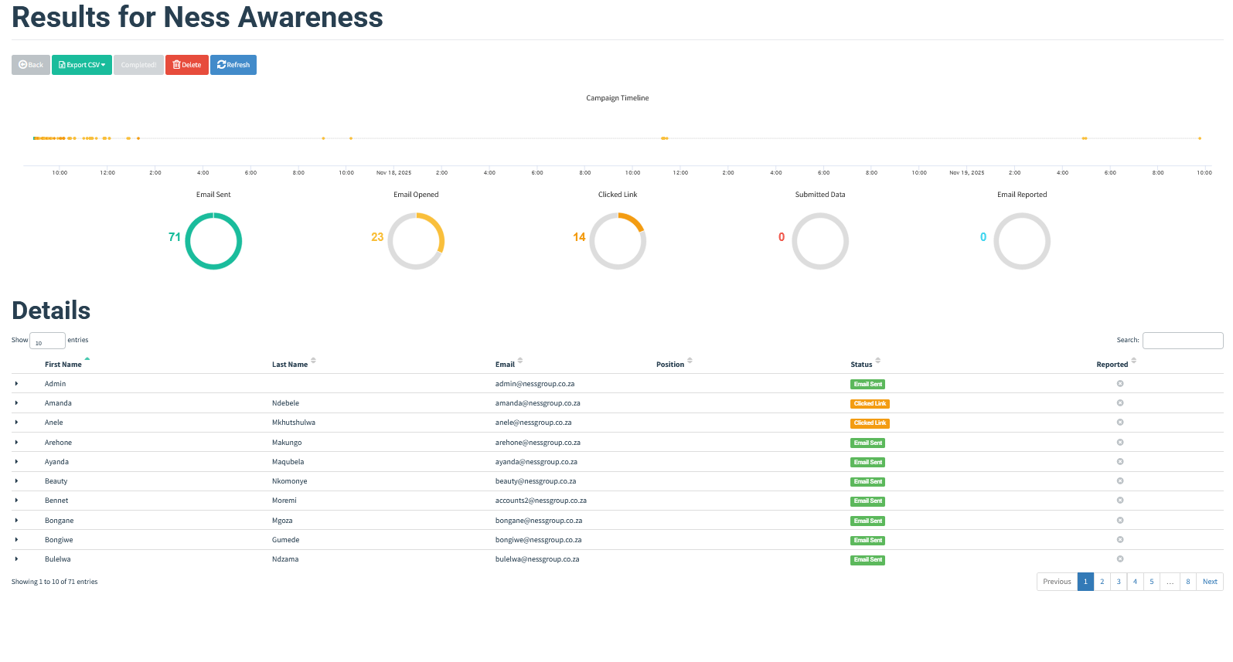

results summary

The following high-level results were recorded during the campaign:

- Total Emails Sent: 71
- Emails Opened: 23
- Links Clicked: 14
- Submitted Data: 0
- No Engagement (Email Sent Only): As per dataset
A detailed breakdown of user responses will be inserted under the following headings using screenshots from the Excel results.

Users who Clicked on the Link:

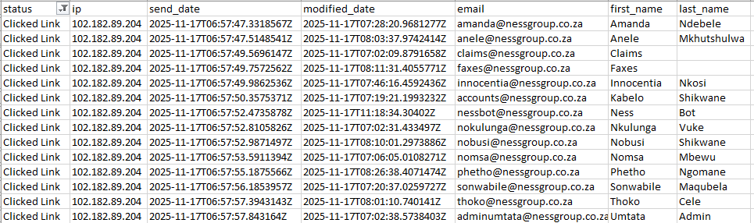

Users who Opened the Email:

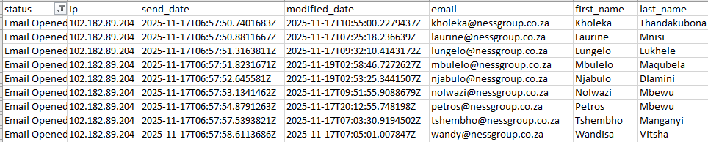

Emails sent but Not Opened:

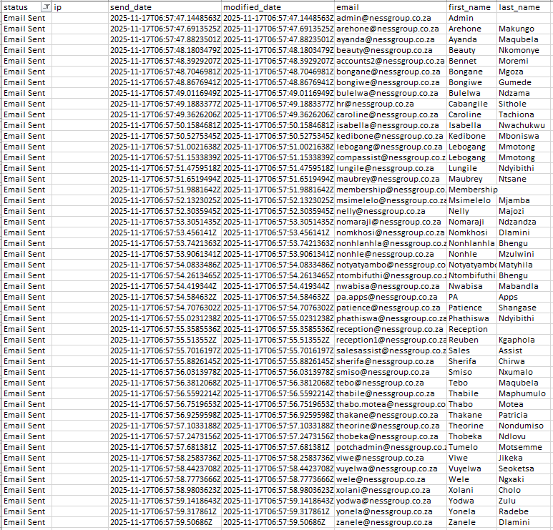

CONCLUSIONS & RECOMMenDATIONS:

The campaign results indicate varying levels of awareness among staff members regarding suspicious email content. A notable number of users clicked on the embedded test link, demonstrating potential vulnerability to phishing attacks. It is recommended that further awareness training be conducted, focusing on recognising phishing attempts and best practices for email security.

